

October 15, 2019

To whom it may concern:

St. Paul’s Episcopal Church is currently soliciting donations for a silent auction to be held as a part of its Advent Fair on December 7, 2019.

Proceeds from the Advent Fair support the mission and ministries of the church.   
St. Paul’s provides financial and in-kind support to programs with local, national, and international impact, including the Bedford Community Table, Cradles to Crayons, Episcopal Relief and Development, and the Children’s Nutrition Program of Haiti.

Please consider donating an item, service, or gift certificate to the auction. St. Paul’s is a registered 501(c)(3) charity. A letter acknowledging your donation will be sent after the auction.

Thank you for your consideration.

Sincerely yours,

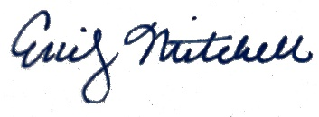

Emily Mitchell

Silent Auction Coordinator

