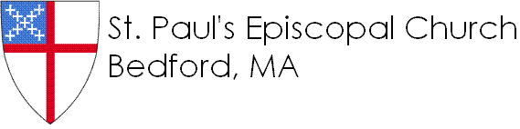

**9/13**: Going to Church

**9/20:** Jeremiah

**9/27**: Amos and Micah

**10/4:** Family Sunday *(No Sunday school)*

**10/11**: Columbus Day weekend *(No SS)*

**10/18:** Ruth and Naomi

**10/25:** Jonah

**11/1:** Family Sunday *(No SS)*

**11/8:** Elijah

**11/15:** Slaves in Egypt

**11/22:** Moses

**11/29:** Pageant practice

**12/6:** Pageant practice

**12/13:** Pageant practice

**12/20:** Christmas Pageant!

**12/27:** Holiday weekend *(No SS)*

**1/3:** Family Sunday *(No SS)*

**1/10:** The Books We Use in Church

**1/17:** Jesus’ Power at Cana

**1/24:** Nicodemus’ Secret Visit

**1/31:** The Woman at the Well

2015-2016

Sessions 1 & 2

School

Sunday

Sunday

2015-2016

Sessions 1 & 2

School

**9/13**: Going to Church

**9/20:** Jeremiah

**9/27**: Amos and Micah

**10/4:** Family Sunday *(No Sunday school)*

**10/11**: Columbus Day weekend *(No SS)*

**10/18:** Ruth and Naomi

**10/25:** Jonah

**11/1:** Family Sunday *(No SS)*

**11/8:** Elijah

**11/15:** Slaves in Egypt

**11/22:** Moses

**11/29:** Pageant practice

**12/6:** Pageant practice

**12/13:** Pageant practice

**12/20:** Christmas Pageant!

**12/27:** Holiday weekend *(No SS)*

**1/3:** Family Sunday *(No SS)*

**1/10:** The Books We Use in Church

**1/17:** Jesus’ Power at Cana

**1/24:** Nicodemus’ Secret Visit

**1/31:** The Woman at the Well