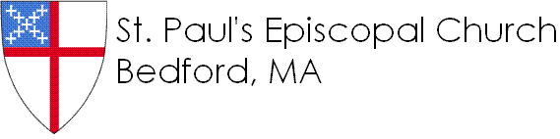

**9/11**: Moses

**9/18:** Amos

**9/25**: Amos

**10/2:** Family Sunday *(No Sunday school)*

**10/9**: Columbus Day weekend *(No SS)*

**10/16:** Jacob and the Angel

**10/23:** Jeremiah

**10/30:** Jeremiah

**11/6:** Family Sunday *(No SS)*

**11/13:** The Season of Advent

**11/20:** The Season of Advent

**11/27:** Family Sunday *(No SS)*

**12/4:** Pageant practice

**12/11:** Pageant practice

**12/18:** Christmas Pageant!

**12/25:** Christmas Day *(No SS)*

**9/11**: Moses

**9/18:** Amos

**9/25**: Amos

**10/2:** Family Sunday *(No Sunday school)*

**10/9**: Columbus Day weekend *(No SS)*

**10/16:** Jacob and the Angel

**10/23:** Jeremiah

**10/30:** Jeremiah

**11/6:** Family Sunday *(No SS)*

**11/13:** The Season of Advent

**11/20:** The Season of Advent

**11/27:** Family Sunday *(No SS)*

**12/4:** Pageant practice

**12/11:** Pageant practice

**12/18:** Christmas Pageant!

**12/25:** Christmas Day *(No SS)*

2016-2017

Session 1

School

Sunday

Sunday

2016-2017

Session 1

School