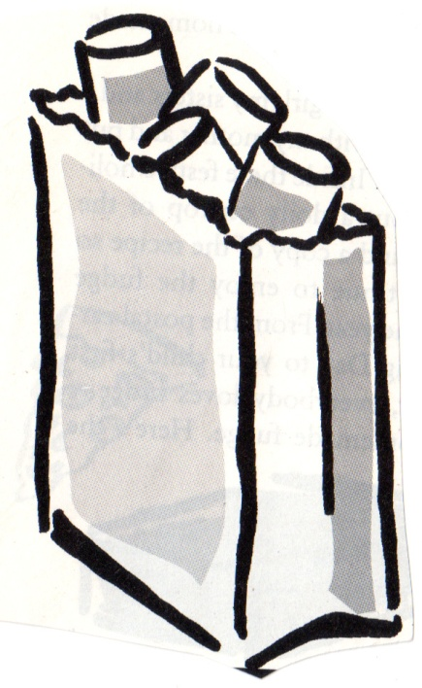
MY GROCERY LIST
MICROWAVEABLE FOODS
Look for foods easily cooked in a microwave
⁪ Success Boil in a Bag rice
⁪ Lipton packets – noodles etc.
⁪ Knorr side dish packets
⁪ Cambell’s Chunky soup –red plastic
⁪ Annie Chun's soups
⁪ Trader Joe’s microwavable foods
⁪ Hormel Compleats meat + potatoes
⁪ Chef Boyardee Lasagna/Ravioi Red top
⁪ Dinty Moore Big Bowls Beef Stew White top
⁪ Select Harvest Chicken Tortilla Green top
⁪⁪ Select Harvest Italian Style Wedding Green top
⁪ Healthy Choice Red Beans and Rice green top
⁪ Microwavable Barilla Pasta
⁪ Microwave Popcorn

Bring contributions to:
St. Paul’s Episcopal Church
100 Pine Hill Road
Bedford, MA 01730
MY GROCERY LIST
MICROWAVEABLE FOODS
Look for foods easily cooked in a microwave
⁪ Success Boil in a Bag rice
⁪ Lipton packets – noodles etc.
⁪ Knorr side dish packets
⁪ Cambell’s Chunky soup –red plastic
⁪ Annie Chun's soups
⁪ Trader Joe’s microwavable foods
⁪ Hormel Compleats meat + potatoes
⁪ Chef Boyardee Lasagna/Ravioi Red top
⁪ Dinty Moore Big Bowls Beef Stew White top
⁪ Select Harvest Chicken Tortilla Green top
⁪⁪ Select Harvest Italian Style Wedding Green top
⁪ Healthy Choice Red Beans and Rice green top
⁪ Microwavable Barilla Pasta
⁪ Microwave Popcorn
Bring contributions to:
St. Paul’s Episcopal Church
100 Pine Hill Road
Bedford, MA 01730

