*“Lost and Found”*

*A sermon by the Rev. Rachel Wildman*

*July 30th, 2017*

Scripture reference: [Matthew 13:31-33,44-52](http://www.lectionarypage.net/YearA_RCL/Pentecost/AProp12_RCL.html" \l "gsp1)

Have any of you seen those bumper stickers that say “Eschew Obfuscation?” They are meant to be funny, ironically arguing for the need for clear communication. Given that scholars say that the parables are probably the aspects of the Gospels that are the closest to what Jesus actually might have said, I feel like if Jesus were alive today, he would have one of those bumper stickers, but he wouldn’t realize the irony.

Nothing like coming back from an extended period away to not one, but 5 obfuscating parables!

So, there is no way I can, or think it would be anywhere near a good idea to even try to address all the good “advice” that is going down in our parable-laden passage this morning. So, I will focus on the two parables that my meditations kept bringing me back to:

* + “The kingdom of heaven is like treasure hidden in a field, which someone found and hid; then in his joy he goes and sells all that he has and buys that field.
  + “The kingdom of heaven is like a merchant in search of fine pearls; on finding one pearl of great value, he went and sold all that he had and bought it.”

In these parables, we hear that inherent to the kingdom are searching and…Finding.

As I was contemplating these parables, I happened to begin reading Barbara Brown Taylor’s first book, *Leaving Church*, a memoir about her life of faith. Taylor is an Episcopal priest, but she speaks of her faith journey in ways that resonate far beyond ordained ministry. Of great relief to my sermon preparation this week, she frames her faith journey in the very terms of our parables-- searching and finding, then losing, and finding once again. Her words opened up a new way of hearing these parables for me. So, I’d like to share an excerpt with you. She speaks about losing, searching, and finding in relation to her vocation as an ordained minister, but I invite you to listen for what of it might resonate with your own losing, searching and finding.

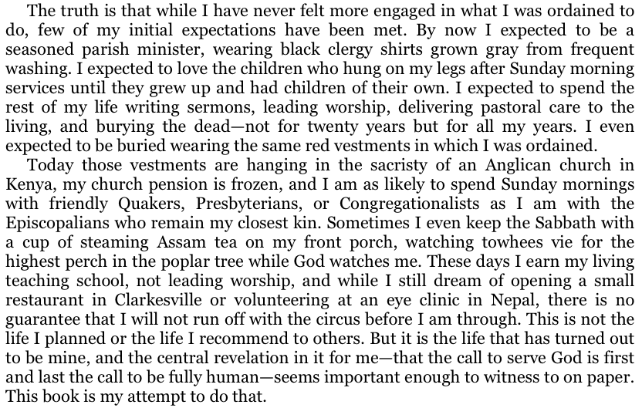

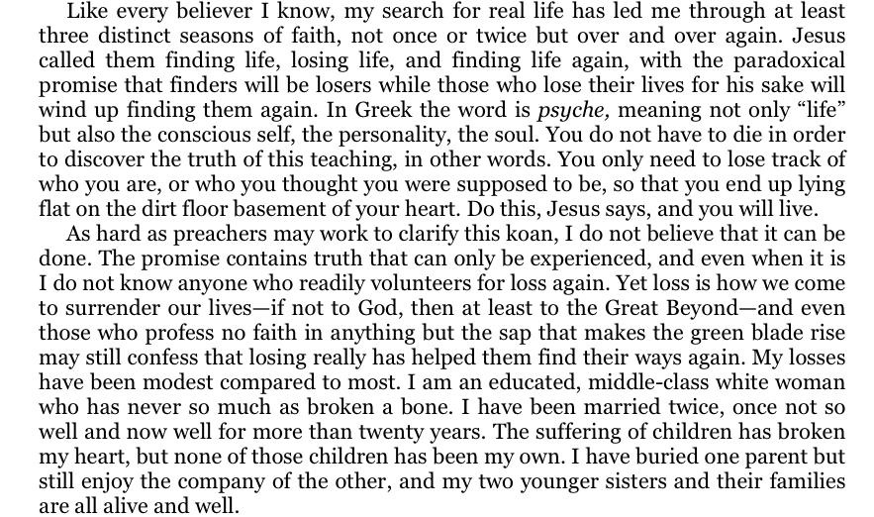

*from the Introduction of Barbara Brown Taylor’s *Leaving Church: A Memoir of Faith*, Harper Collins, 2009You know, I always thought that losing your life meant giving it up for others—turning the focus off of yourself and fully onto others—it meant focusing on what your skills, talents, and passions could do for the world. But my own experience, resonant in the words of Barbara Brown Taylor, has invited me to an entirely new thinking about this. Perhaps losing your life is actually to passionately and determinedly turn to your own self—to rediscover it—to learn where you find joy and life—where you feel able to be you, around whom you feel able to be you, in what places and situations you feel invited and excited to spend time.

I have come to strongly suspect as of late that my ordination is not about anyone else but me—but me being fully me—and that it would have been just as much a divine call had I been fully myself researching something incredibly esoteric with no seeming applicability to the world at all. My ordination allowed me to be more me in the past 5 years, especially so during my mother’s illness and death—this call is perhaps the most self-centered thing I have ever done, or that God will ever do on my behalf…and yet, just as in our Kingdom parables, to lose myself and find it again has been so very joyful—so very valuable that I would give up all I had to gain it.

I was taken by the very clear articulation of Barbara Brown Taylor that our call to wholeness and fullness is a call that persists whether we have “the life we planned, or whether we have, instead, the life that has simply turned out to be ours”, as she phrased it. God calls us to wholeness and vitality in every moment, even when it seems like we hid that treasure in the fields of our life and now can’t remember where.

But if we have misplaced that treasure, are perhaps are still seeking it, how do we find it? Again, Brown Taylor burst open my thinking on this…we must lose track of who we are, or who we think we are supposed to be. She doesn’t ask us to lose who we are, but to lose track of it…to lose evokes such a dark feeling for me. But to lose track of—that evokes the work of childhood—of long summer days of adventure when we forget to check in with our parents—of allowing ourselves to be overtaken by the passion of a moment so fully that we lose track of time, of our surroundings, of what we are “supposed” to be doing, or where we are “supposed” to be.

This happened to me most recently in Haiti—I have told so many of you that one of my favorite parts of the Haiti trip was riding in the back of the flatbed truck to and from clinic every day…. Me the public health expert so devoted to safety—to seat belts and helmets and speed limits—me the one who doesn’t take physical risks and never quite lets loose. I lost track of myself in the back of that truck and boy did I reconnect with my fulllest self. PURE JOY that clearly has stayed with me and lives and breathes in me even 6 months later.

To find ourselves, and therefore our call from God, we need *not* lose ourselves, but lose *track* of ourselves…What lightness and playfulness in the search for wholeness and purpose that opens up!

So, when did that last happen to you? Where were you? Who were you with? What were you doing? Or NOT doing?

I would be inauthentically representing my own current experience, just having lost my mother, if I didn’t note that losing track of ourselves is so very often required during times when we have actually lost ourselves—dark times of grief and loss, of coming to terms with the lives that have turned out to be ours, not the lives we planned to be ours. But, I assure you, moments of playful losing track of still beckon us even in those dark times—moments inviting us to lose track of the feeling that we really should be grieving, not laughing, or that we should be fighting for what we lost, not raising our arms high as we dance unselfconsciously. Or even, an opportunity like this morning for me, to recall a moment in the past when I found wholeness and fullness—a memory that acts as a touchstone I can return to—to live in for a few minutes when I feel like I have actually lost myself.

Take advantage of those invitations—for in losing track of yourself, you just might find that treasure that is the fullest you—the greatest gift to God, and the essence of the Kingdom, itself.

AMEN.