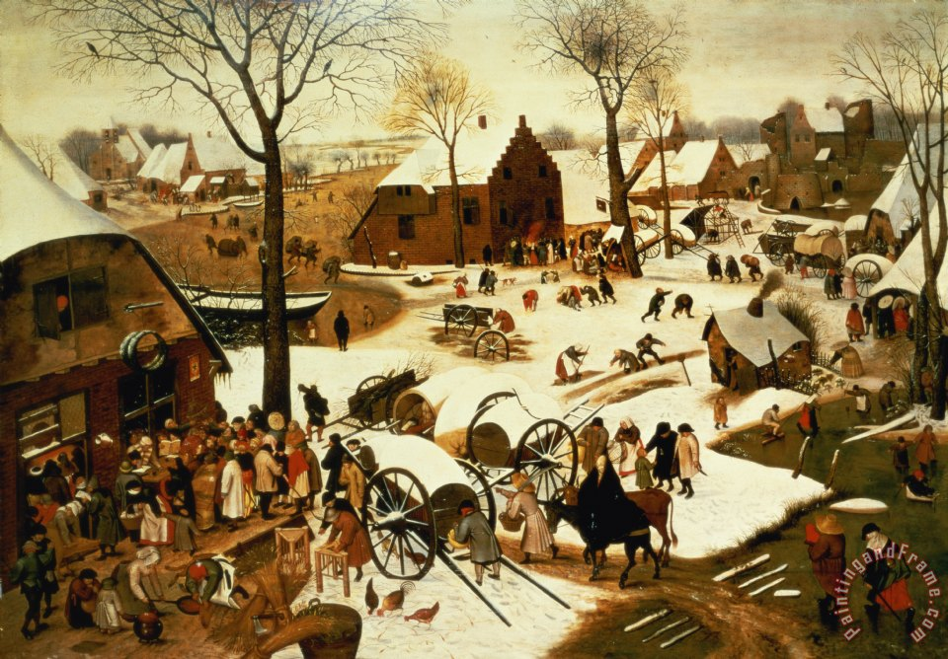

Ordinary Mangers

A Homily for Christmas Eve 2016
By the Rev. Christopher Wendell
St. Paul’s Episcopal Church, Bedford MA

Peter Bruegel the Elder was a Dutch Renaissance painter from the mid-16th century…but you’d hardly recognize his work as Renaissance Art. Unlike his more famous Italian counterparts, who painted half a century earlier, Bruegel’s works reject the heightened sense of self-importance and dramatic theological portrayals found in Leonardo, Raphael, or Titian. Instead, Bruegel was known mostly for painting moments of ordinary peasant country life set in the Dutch villages in which he lived. Many of his works depict strikingly unremarkable secular scenes, with titles such as “Hunters in the Snow” “The Peasant Wedding” or “Children’s Games”.

But there’s a lot more going on in these paintings than just a cataloging of ordinary life, as I discovered when coming upon another of Bruegel’s paintings this past week. At first, I thought it was just another secular scene of village life: a wide-shot view of a small town square crowded with peasants lining up to enter a building, with the hustle and bustle feel of a market day. Beautiful in its simplicity, but hardly remarkable. Until I read the simple title: “The Census at Bethlehem.”

Without that title, you’d hardly recognize the work as a Christmas painting, or even as a piece of religious art at all. Mary and Joseph blend into the scene so perfectly, it’s almost like camouflage. They lack all the artistic symbolism that makes them so easily identifiable in other Renaissance art. There are no angels in the sky, no manger scene out back, the 16th century village is not even decorated for Christmas, and most of the fifty or so people depicted in the painting are simply at their work or crowding around the square. Absent the title, absent the Creator revealing the holiness of this scene, there is nothing to suggest the presence of the miraculous divine reality concealed within this humble ordinary village.

As I gazed at this image of mystery ensconced among the ordinary, it seemed to me like the perfect metaphor for the Feast we celebrate tonight. Or perhaps it was more like an invitation, two invitations, really -- encouraging us to look past the surface trapping of the holiday and open our hearts to the mystery Emmanuel of God-with-us.

The first is an invitation to see the ordinary, unremarkable moments of our imperfect lives as infused, embedded with the presence of God. Too often, we think that the miraculous dramas of the life of faith lie far beyond us, out in some celestial realm of fantasy. The religious worldview often tends to separate the enchanted from the mundane, as if there was a spiritual reality somehow separate from material reality with some kind of impenetrable boundary preventing the Divine Love from being enmeshed in our everyday, inglorious, often grimy, human struggles. This approach keeps God separate; unstained and apart from the messes that we make of our individual and collective lives.

The scandal of the Incarnation is Christianity’s ultimate rejection of any separation between God’s perfection and our muddled humanity. In that manger in Bethlehem, the flesh and the spirit became one in Christ. Divinity became all mixed up with humanity…and there would be no going back. The incarnation is the promise that our ordinary human brokenness is no obstacle to divine love – no obstacle to our receiving it, and no obstacle to our embodying it. Our overstuffed imperfect lives, our daily hustle and bustle, our complicated relationships, our deep yearnings for change, our hopes and dreams for ourselves and for our world, these are no longer petty human dramas irrelevant to the mysteries of God. They are in fact, the very places that the divine mysteries now reside. They matter to God, because that is where God chose to make a home on earth -- not in spangled heaves far above, nor in royal palaces or elite towers, nor even in cathedrals. But in the messy midst of the human, relational, ecological, political, and familial dramas that shape our lives.

If Christmas’ first invitation tonight is to remember that God can infuse the ordinary life of a humble first century family with the Divine Presence, then the second invitation is for us not just to celebrate that this happened to them long ago, but to receive that miracle ourselves, here tonight. What’s so striking about Bruegel’s painting isn’t that it’s set in the 16th century. Rather, it’s that the people in this modern village aren’t celebrating the Christmas holiday – they are living the Christmas story, and doing so blissfully unaware of the its approaching climax. It is like they are characters in a Christmas pageant, except instead of their pageant being a re-telling of something that happened long ago, it is instead an enactment of a spiritual truth that exists in every age. In every time and place. In every community – new, fresh, as if it was the first time, the only time -- the time not when we remember the miracle, but when it happens to us. When God comes to us.

Are we willing to do more than just revel in the Christmas story? Are we willing to live it and, maybe more importantly, to let it live in us? Are we willing to believe that God dwelt on earth not just 2000 years ago in a manger, but also 500 years ago in an ordinary Norwegian village. And also five days ago in Aleppo where refugees were finally able to leave their war-torn city and find safety. And also five hours ago in the Bedford high school gymnasium where dozens of men and women in red suits gave up their evening to make the Christmas spirit more real for the children of this town? And five minutes ago when perhaps, in a moment of song or prayer, God came to life again in the heart of someone in this very room? Are we willing to call these moments Nativities, sites in which God is again born among us? Tonight we do not just celebrate a past event and long for it to re-occur. We recognize that it is occurring in every ordinary moment. Including ours. Embedded in every heart, including yours.

We tend to think of Christmas as the most wonderful time of the year. The special time. The thing we wait for every year. And so our celebrations of Christmas tends to be about the enchanting, extraordinary things we do once a year: putting trees in our homes, sunrise shopping on black Friday, surprise family visits, sumptuous meals, year-end charitable giving.

But the Incarnation is about the opposite: it is about the ordinary times being made holy; about blessing our daily routines, our ordinary struggles to respond to the vulnerability of others with kindness, faithfulness, and love in a world addicted to power, success and control. The Incarnation is about the trust that God places is us, not just in our leaders, but in the hearts of every human person, to live with love for all of creation in our hearts.

The true invitation of Christmas is to notice Christ being born -- not tonight, when we have all these decorations and songs and prayers to help us, but in all our ordinary places and times. On the third Tuesday in July, when you offer a ride in our air conditioned car to the woman on the Great Road hoofing it in the heat to Stop and Shop. Or on the third Saturday in January, standing out in the cold wind of Boston Common to proclaim the dignity of all people. Or after a second glass of wine on some random Thursday night, when you realize that life is short, and it’s time to really start loving your loved ones. That’s where God is being made real. Not in a straw manger 2,000 years ago and 5,000 miles away, but every day, ensconced within the ordinary mangers all around us, calling us to draw near. By the grace of God may we find our way to those mangers, and kneel, and open our hearts to Christ’s love. Amen.

